3.1THREE DIMENSIONAL CONCEPTS

We can rotate an object about an axis with any spatial orientation in three-dimensional space. Two-dimensional rotations, on the other hand, are always around an axis that is perpendicular to the xy plane. Viewing transformations in three dimensions are much more cornplicated because we have many more parameters to select when specifying how a three-dimensional scene is to be mapped to a display device. The scene description must be processed through viewing-coordinate transformations and projection routines that transform three-dimensional viewing coordinates onto two-dimensional device coordinates. Visible parts of a scene, for a selected view, must be identified; and surface-rendering algorithms must he applied if a realistic rendering of the scene is required.

3.2 THREE DIMENSIONAL OBJECT REPRESENTATIONS

Graphics scenes contain many different kinds of objects. Trees, flowers, glass, rock, water etc.. There is not any single method that we can use to describe objects that will include all characteristics of these different materials.

Polygon and quadric surfaces provide precise descriptions for simple Euclidean objects such as polyhedrons and ellipsoids.

Spline surfaces and construction techniques are useful for designing aircraft wings, gears and other engineering structure with curved surfaces.

Representation schemes for solid objects are often divided into two broad categories
  - Boundary representations (B-reps)
  - Space-partitioning representations
- Boundary representations
  - Inside and outside of objects are defined by this representation. E.g., polygon facets, spline patches
- Space-partitioning representations
  - The inside of the object is divided into non-overlapping regions and the object is represented as a collection of these interior components. E.g., octree representation

3.3 POLYGON SURFACES

Polygon surfaces provide precise descriptions for simple Euclidean objects such as polyhedrons and ellipsoids. A three dimensional graphics object can be represented by a set of surface polygons. Many graphic systems store a 3 dimensional object as a set of surface polygons. This simplifies and speeds up the surface rendering and display of objects. In this representation, the surfaces are described with linear equations. The polygonal representation of a polyhedron precisely defines the surface features of an object.In Figure 3.1, the surface of a cylinder is representedas a polygon mesh. Such representations are common in design and solid-modeling applications, since the

wireframe outline can be displayed quickly to give a general indication of the surface structure.
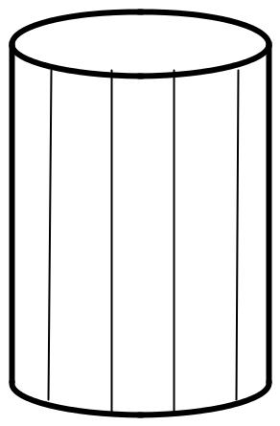

(Figure 3.1, Wireframe representation of a cylinder with back (hidden) lines removed)

3.4 POLYGON TABLES

We know that a polygon surface is defined by a set of vertices. As information for each polygon is input, the data are placed in to tables that are used in later processing, display and manipulation of objects in the scene.

Polygon data tables can be organized in to 2 groups: geometric tables and attribute tables.Geometric data tables contain vertex coordinates and parameters to identify the spatial orientation of the polygon surfaces. Attribute information for an object includes parameters specifying the degree of transparency of the object and its surface reflexivity and texture characteristics.

A suitable organization for storing geometric data is to create 3 lists, a vertex table, an edge table and a polygon table. Coordinate values for each vertex is stored in the vertex table. The edge table contains pointers back to the vertex table to identify the vertices for each polygon edge. The polygon table contains pointers back to the edge table to identify the edges for each polygon.

An alternative arrangement is to modify the edge table to include forward pointers in to the polygon table so that common edges between polygons could be identified more rapidly.

Additional geometric formation that is usually stored in the data tablesincludes the slope for each edge and the coordinate extents for each polygon. As vertices are input, we can calculate edge slopes, and wecan scan the coordinate values to identify the minimum and maximum x, y, and z values for individual polygons. Edge slopes and bounding-box information for the polygons are needed in subsequent processing, for example, surface rendering. Coordinate extents are also used in some visible-surface determination algorithms

The moreinformation included in the data tables, the easier it is to check for errors. Therefore,error checking is easier when three data tables (vertex, edge, and polygon)are used, since this scheme provides the most information. Some of the tests

that could be performed by a graphics package are (1) that every vertex is listed as an endpoint for at least two edges, (2) that every edge is part of at least one polygon, (3) that every polygon is closed, (4) that each polygon has at least one shared edge, and (5) that if the edge table contains pointers to polygons, every edge referenced by a polygon pointer has a reciprocal pointer back to the polygon.

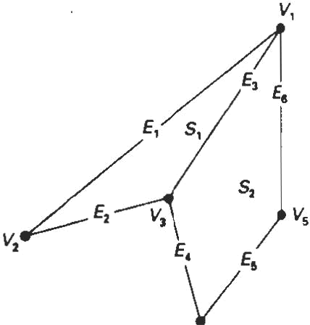

VERTEX |  | EDGE TABLE
VERTEX |  | EDGE TABLE |  | POLYGON-SURFACE
TABLE |  |  |  | TABLE
TABLE |  | E1:V1,V2 |  | TABLE
V1:x1,y1,z1 |  | E1:V1,V2
V1:x1,y1,z1 |  | E1:V1,V2 |  | S1:E1,E2,E3
V1:x1,y1,z1 |  | E2:V2,V3 |  | S1:E1,E2,E3
V2:x2,y2,z2 |  | E3:V3,V1 |  | S2:E3,E4,E5,E6
V3:x3,y3,z3 |  | E4:V3,V4
V4:x4,y4,z4 |  | E4:V3,V4
V4:x4,y4,z4 |  | E5:V4,V5
V5:x5,y5,z5 |  | E5:V4,V5
V5:x5,y5,z5 |  | E6:V5,V1

3.5 PLANE EQUATIONS

When working with polygons or polygon meshes, we need to know the equation of the plane in which the polygon lies. We can use the coordinates of 3 vertices to find the plane. The plane equation is

Ax + By + Cz + D = 0

The coefficients A, B and C define the normal to the plane. [A B C]. We can obtain the coefficients A, B, C and D by solving a set of 3 plane equations using the coordinate values for 3 non collinear points in the plane. Suppose we have 3 vertices on the polygon (x1, y1, z1), (x2, y2, z2) and (x3, y3, z3).

Ax + By + Cz + D = 0

(A/D) x1 + (B/D) y1 + (C/D) z1 = -1

(A/D) x2 + (B/D) y2 + (C/D) z2 = -1

(A/D) x3 + (B/D) y3 + (C/D) z3 = -1

the solution for this set of equations can be obtained using Cramer‘s rule as,

A = 1 y1 z1

1 y2 z2

1 y3 z3

B = x1 1 z1

x2 1 z2

x3 1 z3

C = x1 y1 1

x2 y2 1

x3 y3 1

D = _ x1 y1 z1

x2 y2 z2

x3 y3 z3

We can write the calculations for the plane coefficients in the form

A = y1 (z2 - z3) + y2 (z3 – z1) + y3 (z1 – z2)

B = z1 (x2 - x3) + z2 (x3 – x1) + z3 (x1 – x2)

C = x1 (y2 - y3) + x2 (y3 – y1) + x3 (y1 – y2)

D= - x1 (y2 z3 – y3 z2) – x2 (y3 z1 – y1 z3) – x3 (y1 z2 – y2 z1)
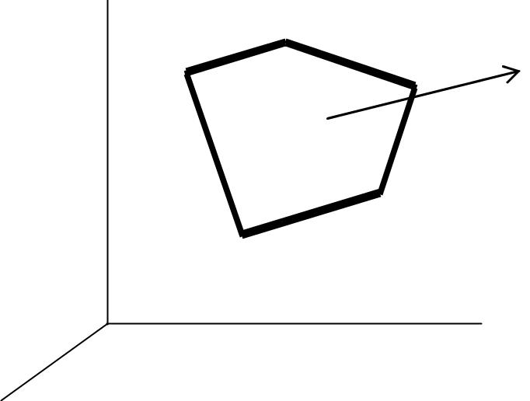

N=(A,B,C)

(Figure 3.2, The vector N, Normal to the surface of a plane described by the equation

Ax + By + Cz + D = 0 ,has Cartesian components(A,B,C))

If there are more than 3 vertices, the polygon may be non-planar. We can check whether a polygon is nonplanar by calculating the perpendicular distance from the plane to each vertex. The distance d for the vertex at (x, y, z) is

d = Ax + By + Cz + D

(A² + B² + C²)

The distance is either positive or negative, depending on which side of the plane the point is located. If the vertex is on the plane, then d = 0.

We can identify the point as either inside or outside the plane surface according to the sign of Ax + By + Cz + D.

If Ax + By + Cz + D < 0, the point (x, y, z) is inside the surface.

If Ax + By + Cz + D > 0, the point (x, y, z) is outside the surface.

3.6 POLYGON MESHES

One type of polygon mesh is thetriangle strip. This function produces n - 2 connected triangles,as shown in Figure: 3.3, given the coordinates for n vertices. Another similar function is the quadrilateralmesh,which generates a mesh of (n - I) by (m - 1) quadrilaterals, given the coordinates for an n by m array of vertices. Figure: 3.4 shows 20 vertices forming a mesh of 12 quadrilaterals

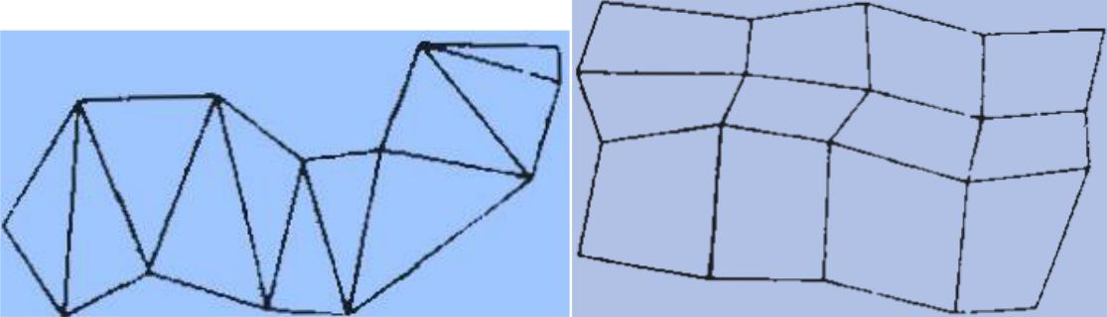

(Figure: 3.3 A triangle strip formed with(Figure: 3.4 shows 20 vertices forming a

11 triangles connecting 13 vertices) mesh of 12 quadrilaterals)

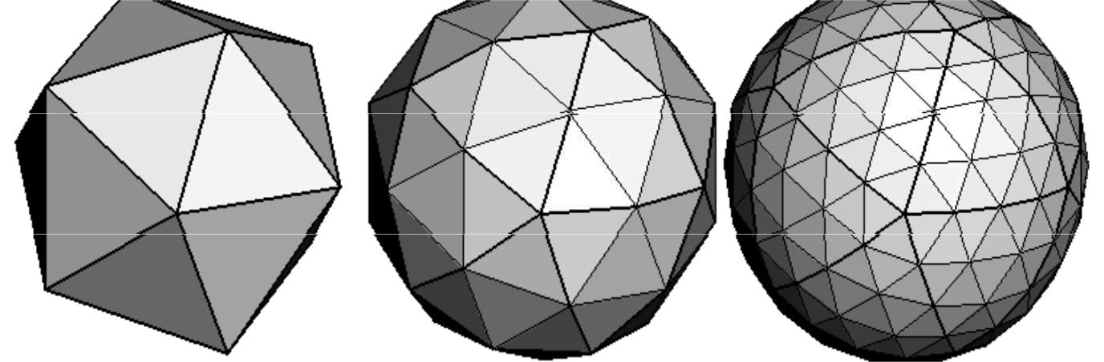

20 triangles 80 triangles 320 triangles

(Figure: 3.5, Examples for triangle mesh with number of vertices)

Highquality graphics systems typically model objects with polygonmeshes and set up a database of geometric and attribute information to facilitate processing of the polygon facets. Fast hardware-implemented polygon renderers are incorporated into such systems with the capability for displaying hundreds of thousands to one million br more shaded polygons per second (usually triangles), including the application of surface texture and special lighting effects.

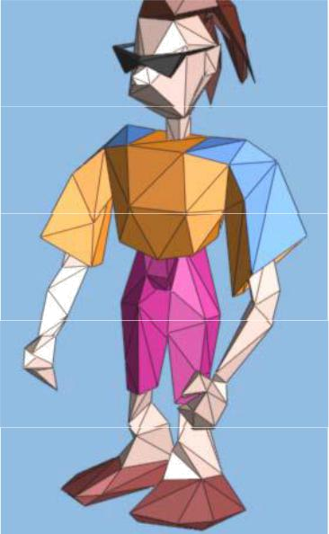

(Figure: 3.6, Example for triangle mesh for an image)

3.7 QUADRIC SURFACES

These are frequently used class of objects. Quadric surfaces are described with second-degree equations. (Quadratics)

The examples of quadric surfaces are spheres, ellipsoids, tori, paraboloids and hyperboloids.

Spheres and ellipsoids are common elements of graphic scenes.

Sphere

A spherical surface with radius r centered on the coordinate origin is defined as

the set of points (x, y, z) that satisfy the equation

x² + y² + z² = r²
in parametric form, the equation of a sphere is

x = r. Cos Ǿ. Cosθ -∏/2 <= Ǿ<= ∏/2

y = r. Cos Ǿ. Sin θ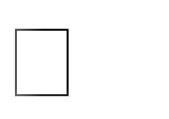 -∏<= Ǿ<= ∏

z = r. sinǾ

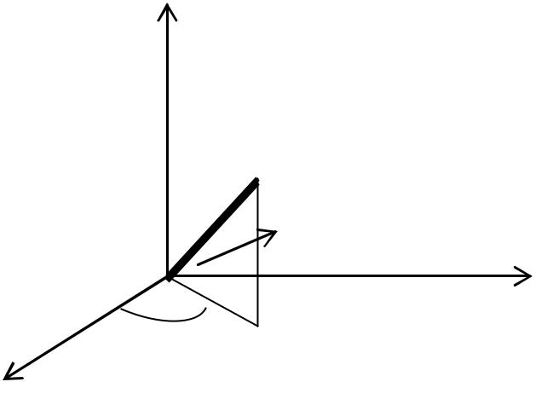

z

P=(x,y,z)

Ǿ

y

Θ

x

(Figure: 3.7, Parametric coordinate position(r,θ,Ǿ) on the surface of a sphere with radius r)

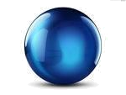

Ellipsoid

An ellipsoidal surface is described as an extension for a spherical surface, where the radii in 3 mutually perpendicular directions can have different values. The points over the surface of an ellipsoid centered at the origin is

(x/r_{x})² + (y/r_{y})² + (z/r_{z})² = 1
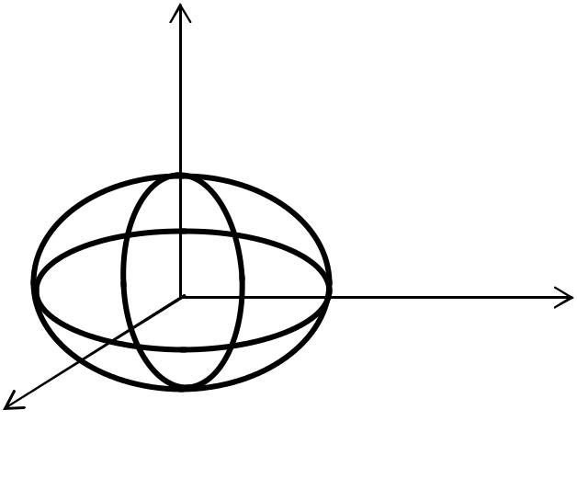

z

r_{z}

r_{y}

y

- ^{r}x
(Figure: 3.8, An ellipsoid with radii r_{x}, r_{y}, andr_{z}centered on the coordinate origin)

The parametric representation for the ellipsoid in terms of the latitude angle Ǿ and the longitude angle θ in Figure: 3.8 is

x=r_{x}cosǾcosθ -∏/2 <= Ǿ <= ∏/2

y=r_{y}cosǾsinθ -∏ <= Ǿ <= ∏
- = r_{z}. sin Ǿ

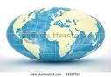

Torus

The torus is a doughnut shaped object.It can be generated by rotating a circle or other conic about a specified axis. The Cartesian representation for points over the surface of a torus can be written as
⌊ √( ) ( ) ⌋ ( )

We can describe the parametric representation of a torus are similar to those for an ellipse, except that angle Ǿ extends over 360º.The parametric representation for the
etorus in terms of the latitude angle Ǿ and the longitude angle θ
x=r_{x}(r+cosǾ)cosθ, -∏<= Ǿ <= ∏
y=r_{y}(r+cosǾ)sinθ, -∏ <= Ǿ <= ∏
z = r_{z}. sin Ǿ

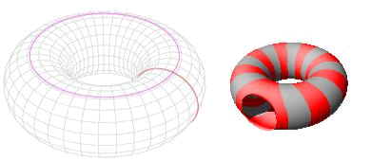

3.8 SUPER QUADRATICS

These objects are a generalization of the quadric representations. Super quadraticsis formed by incorporating additional parameters in to the quadric equations. It is for providing increased flexibility for adjusting object shapes.

Super ellipse

The Cartesian representation for a super ellipse is obtained from the equation of an ellipse by allowing the exponent on the x and y terms to be variable.

The equation of a super ellipse is
( ) ⁄ +( ) ⁄

The parameter s can be assigned any real value. When s = 1, we get an ordinary

ellipse. Corresponding parametric equations for the superellipse can be expressed as
x=r_{x}cos^{s}θ, -∏<= Ǿ <= ∏

y=r_{y}sin^{s}θ,

.,;,·.,;

Figure 3.9 illustrates super circle shapes that canbe generated using various values for parameter s.

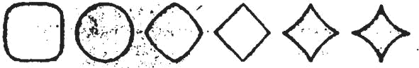

.5 1.0 1.5 2.0 2.3 3.0

(Figure: 3.9 Super ellipses plotted with different values for parameter s and withr_{x}=r_{y})

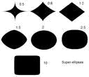

Super ellipsoid

The Cartesian representation for a super ellipsoid is obtained from the equation of an ellipsoid.
.[( ) ⁄ ( ) ⁄ ] ( ) ⁄

For s1 = s2 = 1, we will get an ellipsoid.

The parametric equations for super ellipsoid are
x=r_{x}cos^{s1}Ǿcos^{s2}θ, -∏/2<= Ǿ <= ∏/2
y=r_{y}cos^{s1}Ǿsin^{s2}θ, -∏<=θ <= ∏
z=r_{z}sin^{s1}Ǿ

These shapes can be combined to create more complex structures such as furniture, threaded bolts and other hardware.


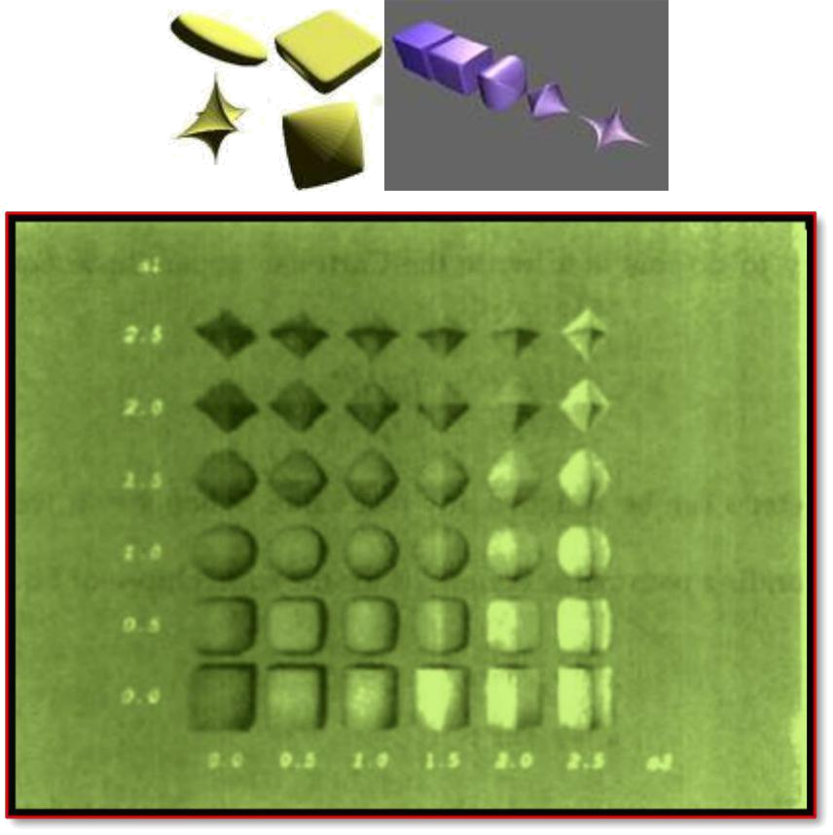

(Figure: 3.10Super ellipsoids plotted with different values for parameters
s1and s2 and with r_{x}= r_{y}= r_{z}).

3.9 BLOBBY OBJECTS

Some objects do not maintain a fixed shape, but change their surface characteristicsin certain motions or when in proximity to other objects. Examples in this class of objects include molecular structures, water droplets and other liquid effects,melting objects, and muscle shapes in the human body. Theseobjects can bedescribed as exhibiting "blobbiness" and are often simply referred to as blobbyobjects, since their shapes show a certain degree of fluidity.

A molecular shape, for example, can be described as spherical in isolation,but this shape changes when the molecule approaches another molecule. Thisdistortion of the shape of the electron density cloud is due to the "bonding" thatoccurs between the two molecules. Figure: 3.11illustrate the stretching, snapping, and contracting effects on molar shapes when two molecules moveapart. Thesecharacteristics cannot be adequately described simply with sphericalor elliptical shapes. Similarly, Figure: 3.12shows muscle shapes in a human arm,which exhibit similar characteristics.

Several models have been developed for representing blobby objects as distributionfunctions over a region of space. One way to do this is to model objectsas combinations of Gaussian density functions, or "bumps" (Figure: 3.13).


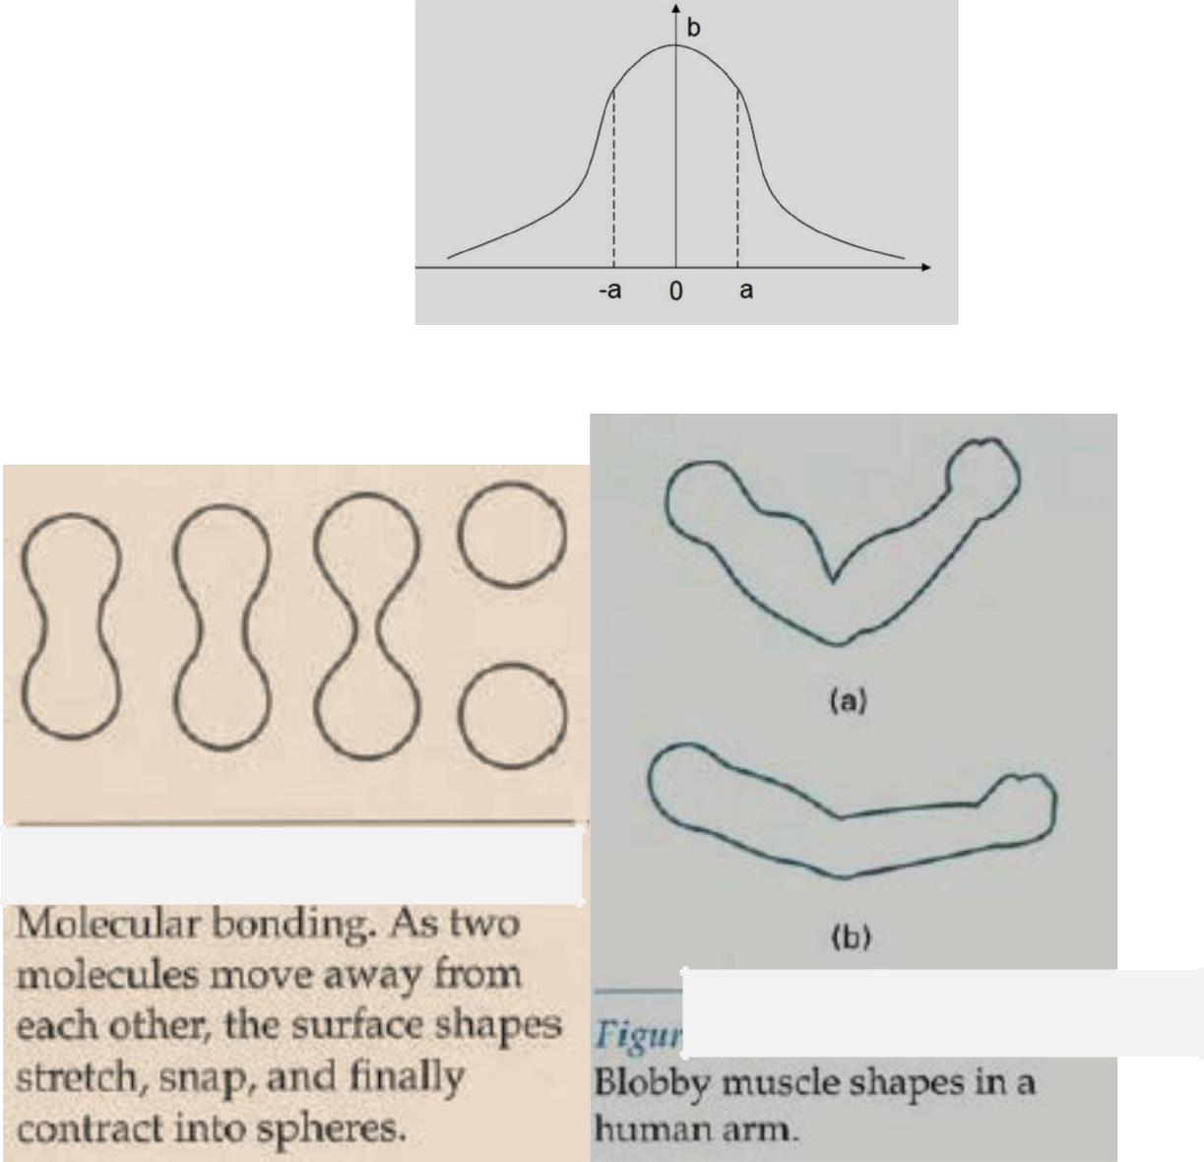

Figure: 3.11

Figure: 3.12

A surface function is then defined as

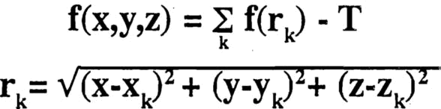

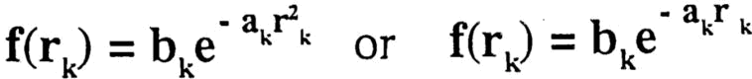

Where

Parameter T is some specified threshold, and parameters a and b are used to adjust the amount of blobbiness of the individual objects. (Negativeb–dents)


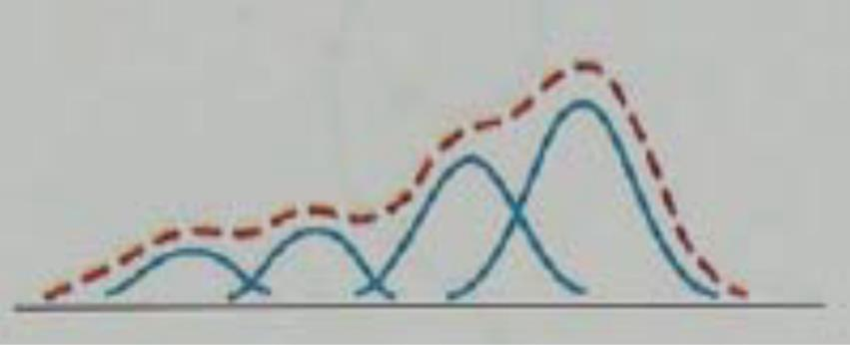

(Figure: 3.13,A composite blobby object formed with four Gaussian bumps)

Other methods for generating blobby objects use density functions that fall off to 0 in a finite interval, rather than exponentially.

